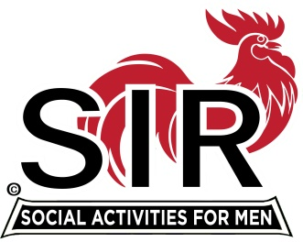
Las Trampas Branch 116
BEC Meeting Agenda
November 21st, 2022, 9:15 AM at Boundary Oak

The Mission of SIR is to enhance the lives of our members through fun activities, events and luncheons – while making friends for life.

9:15 am Call to order; Asst Secretary, Alan Pope, confirm a quorum and Approval of Oct 17th, 2022 BEC meeting minutes
9:20 Standing Reports
- Treasurer – Alan Fitzgerald – Financial Update and 2023 Budget Considerations
- Luncheon Report – Mike Schneider
- Nov Boundary Estimated Count
- 2023 Contract Meeting with Boundary Oak and Potential Lunch Subsidy

- Membership – Phil Goff
- RAMP Department Head Reports:
- Recruitment, Don Schroeder
- Activity Coordinator Mike Ward
- Member Relations David Harris
- Publicity Al Farbman
- Covid Compliance - Kevin Donahue (BA.5 and any related updates etc.)
- Any new developments?
9:40 Little SIR Updates – Roger Craig
Speaker Update
Birthday Boys

9:50 Misc. Updates & New Business

- Holiday Party Dec 14th at Boundary Oak Update, Alan Pope
- Assessment Team for Retention and Growth Update, Fred Wachowicz
- Area Governor Updates, Michael Barrington
- 2023 Roster Book Planning, Roger Craig
- Volunteers Needed: Recruiting Assistants, Speaker Team Member, Member Relations Assistants, Activity Leader Assistants
10:15 am Adjourn; For Lunch Preparations

